The background soo eats image needs to be changed to this and the font of the SOO EATS title to : Alfa Slab One


also change the logo as well with the above picture
the name for chicken steak and rice needs to be updates as chicken steak and fried rice everywhere

the tandoori wrap image needs to be updated:
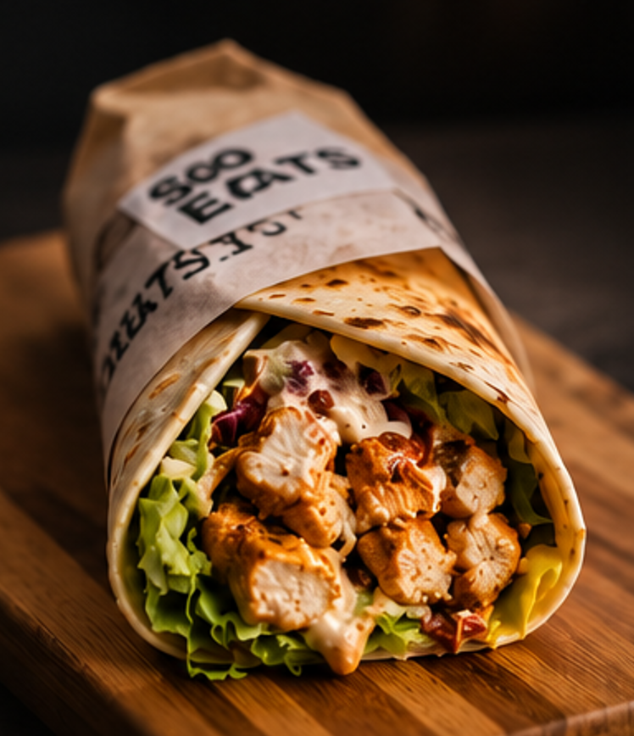

Tandoori wrap

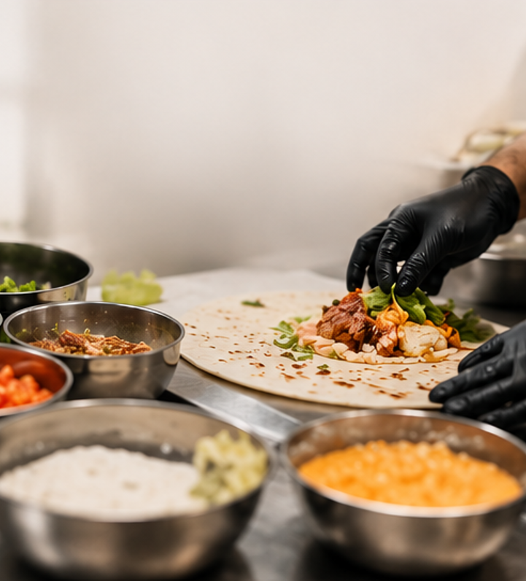

Our mission

Use this image for background as well


Our vision

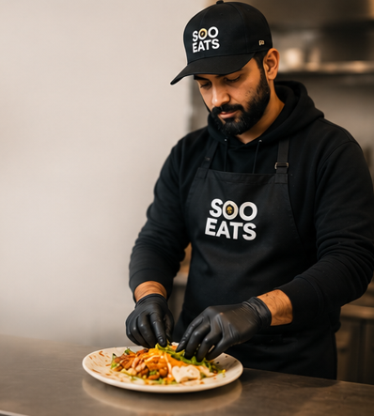

Our story

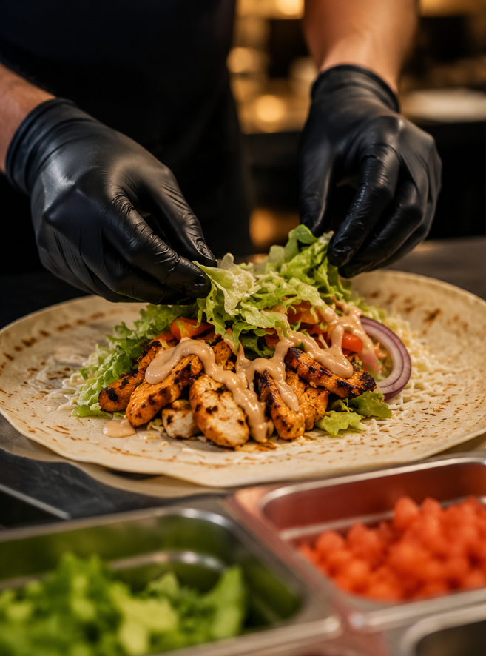

The 1st image inside our mission

Our menu section

Change the tandoori wrap image

Update the price :
breakfast : protein pancake : $12.99
signature wrap : price is $18.99

make it like : regular and large when the customer is trying to add it in the cart
regular price is $12.99 ; large price is $18.99
serving for regular is 2 large is 4

for tandoori wrap also perform the same task price is also same as protein wrap

nutrition info section
blur the image completely for protein coffee and protein cheesecake update the tandoori wrap image

calorie content needs to be update as mentioned below:
pancake
778 64g 91g 16g
Cal Protein carbs fats

Signature wrap
1032 86g 80g 38g
Cal Protein carbs fats
large - Serving 4
Signature wrap
516 43g 40g 19g
Cal Protein carbs fats
regular - Serving 2

Tandoori wrap
1032 102g 73g 35g
Cal Protein carbs fats
Large – serving 4

Tandoori wrap
516 51g 37g 17g
Cal Protein carbs fats
Regular – serving 2

Chicken steak and fried rice
706 35g 63g 34g
Cal Protein carbs fats

Protein pasta
1120 77g 117g 33g
Cal Protein carbs fats

Protein coffee
X Xg Xg Xg
Cal Protein carbs fats

Strawberry protein ice-cream
190 23g 10g 06g
Cal Protein carbs fats

Blueberry protein ice-cream
195 23g 12g 06g
Cal Protein carbs fats

Contact info needs updated

Phone: 705-975-7396
Ig: soo__eats_
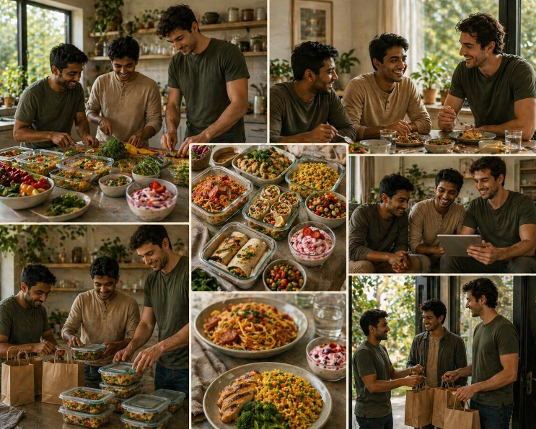
Email id: sooeats1@gmail.com

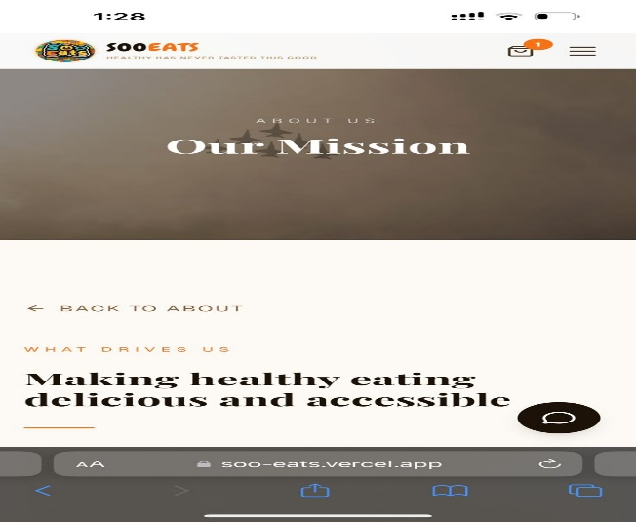

Update the above picture here in place of our mission

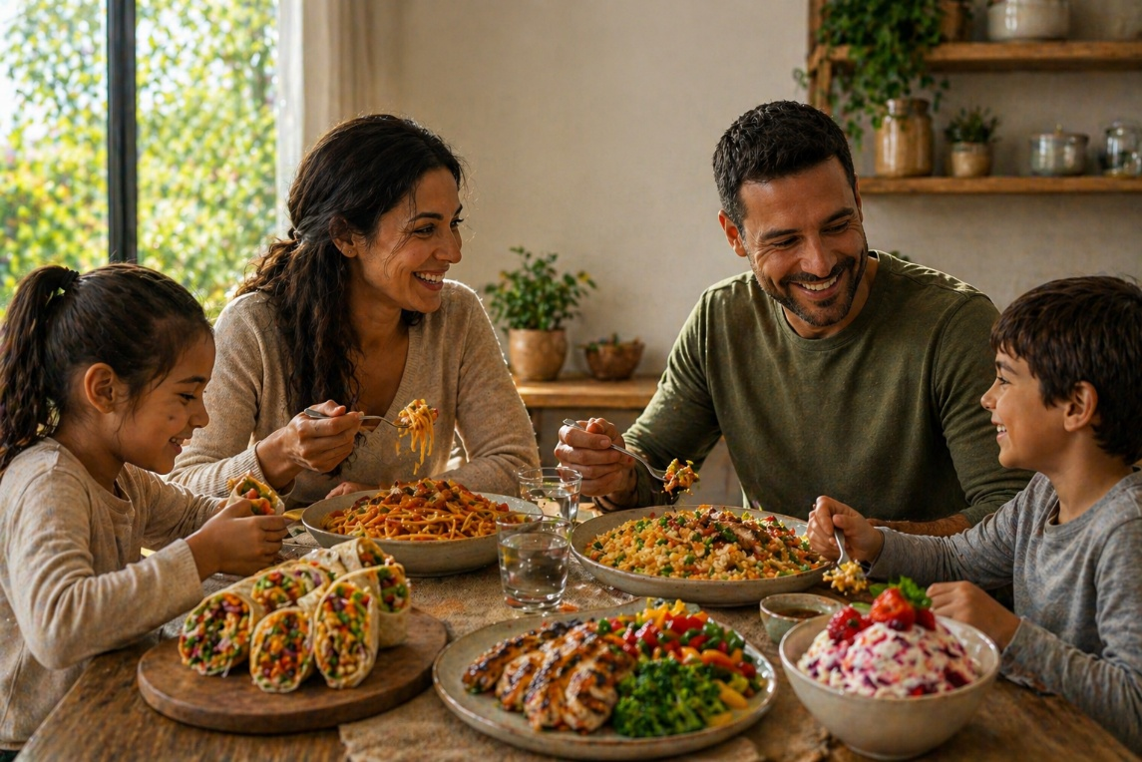

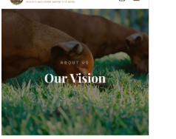
Put the above picture in place of our vision

inside the vision tab remove the two image from the middle and instead of that replace it with the logo make the logo circular in shape use the picture below



